

**Social Story**

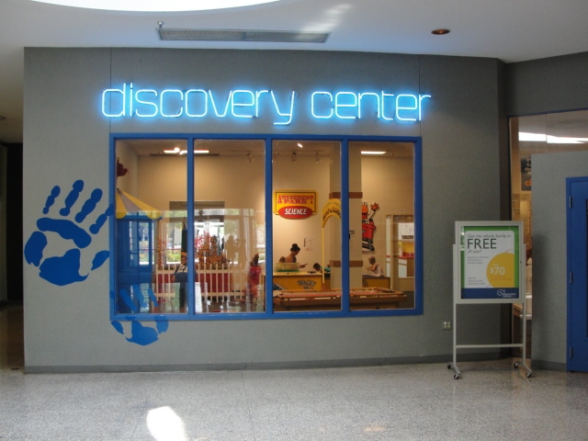

Discovery Center Museum

711 North Main Street

Rockford, IL  61103

(815) 963-6769

[www.discoverycentermuseum.org](http://www.discoverycentermuseum.org)

When I go to Discovery Center Museum

Social Story

When I go to Discovery Center Museum

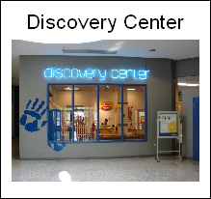

Discovery Center Museum is a fun place to see and do many activities.

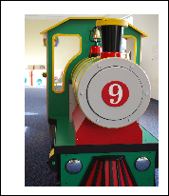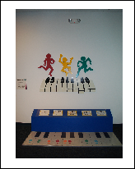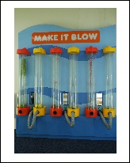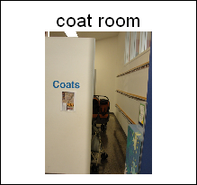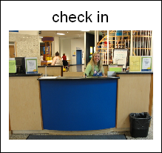

There are many great things for me to see

and do at the museum.

I will check in at the front desk.

I will hang my coat in the coat room. I will leave extra items in the coat room. My hands will be free to explore.

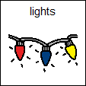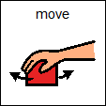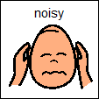

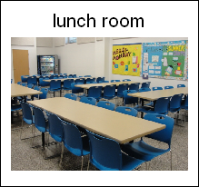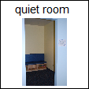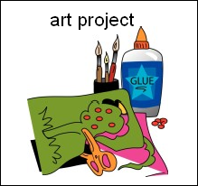

Some things make sounds,

others move or have bright

lights.

I can use my words to leave an activity if I need a break.

There are many places to take a break.

1. I can read a book/quiet time.
2. I can eat a snack in the lunch room.
3. I can go to the bathroom.
4. I can do an art project.

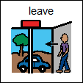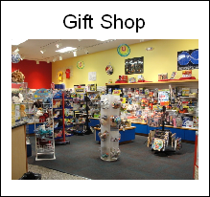

When I am all done, I will get my coat and extra items from the coat room and leave.

I will have a great time at Discovery Center Museum. I may have a choice to visit the Museum Gift Shop.

**Visual Tools Created by**

The Autism Program Service Center – Rockford

A program of Easter Seals Metropolitan Chicago

Symbols in this story are products of Mayer Johnson (www.mayer-johnson.com)